**Part 2: Design Alternatives**

Lagat, Reynette Micah

Sian, David Anthony

1. **Project Description**

Trisakay is a tricycle riding app that allows both drivers and passengers to have a more convenient experience when it comes to commuting. For drivers, the app should allow them to more easily locate potential passengers along their chosen route. For passengers, the app should allow them to quickly identify drivers in their area that are along their chosen route so that they can more easily catch a ride. Overall, it should improve local commuting experiences for both drivers and passengers in subdivisions that have available tricycle riders in them.

1. **Requirements Summary**

The following key requirements will be taken into consideration for the development of this project:

1. **User Centric Design –** The app should have a pleasant and visually appealing design that makes it easier for users to look at, while also making sure that the design is not too distracting.
2. **Easy-to-use Interface –** The app should be straightforward to ensure that users do not have a hard time navigating the app.
3. **Real-time Notifications –** The app should be able to relay information in real-time for all users.
4. **Intuitive User Experience –** The app should be made so that it does not confuse both a driver’s and a passenger’s perception of their current location.
5. **Design Space**

During the design phase of the app, some questions came into mind during development that have altered the final results of the app’s overall design. The following questions were as follows:

**What requirements may be difficult to realize?**

The overall tracking features of each tricycle and passenger in a given area could prove to be challenging, since the data acquired cannot be guaranteed to be 100% accurate and could have some delays. A key issue that arises from this would be inconvenience for all users, since the location of any given user could be delayed as well, thus causing confusion.

**What are some tradeoffs that you should or did explore?**

One tradeoff we made was simplicity over functionality. To summarize the context, the initial design would’ve made some extra features available, such as direct messaging between riders and passengers for easier communication. However ultimately, it was decided to keep the app simple and straightforward, as to not confuse users from the main purpose of the app.

**Which tasks will be easiest to support? Which** **are the hardest?**

The real-time GPS system for the app should be relatively easy to implement, as there are already APIs that are made for this specific task. The hardest to implement would be the route tracking, since each individual driver has their own route that may need to be set themselves.

1. **Design Summary**

Considering the functionality of the app, two fundamental design alternatives were considered, but were ultimately discarded for the sake of user experience. This is because TriSakay is designed to be a simple yet convenient app for all users that should be straightforward with its use. So, as to not convolute this principle, these alternatives were ultimately not pursued. The following alternatives were as follows: a social network system for all users, and a ride history function.

For the social network system, the initial idea was for users to freely communicate with each other for better coordination, especially between riders and passengers. However, two major flaws came to mind after this was proposed. First, this system could potentially be too distracting for all users, which can be especially dangerous for drivers who are not allowed to text while driving. Second, and more importantly, the system was irrelevant to the original purpose of TriSakay, which would be to make tricycle commuting more convenient for all users.

For the ride history function, this proposal was more so for tracking purposes, in case users wanted to view it for their own purposes. However, after some deliberation, it was decided that this function would be quite niche, and that actually tracking each ride would be tedious for users as well since it would likely need input from the users themselves, particularly when they ride the tricycle and arrive at their destination.

1. **The Designs**

**Storyboards**

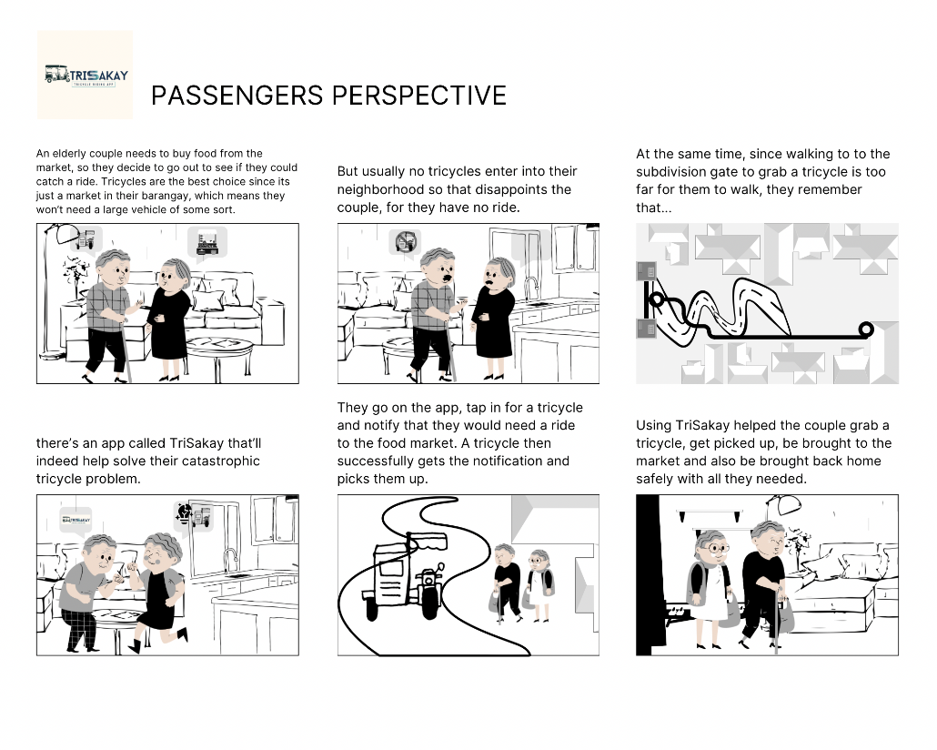

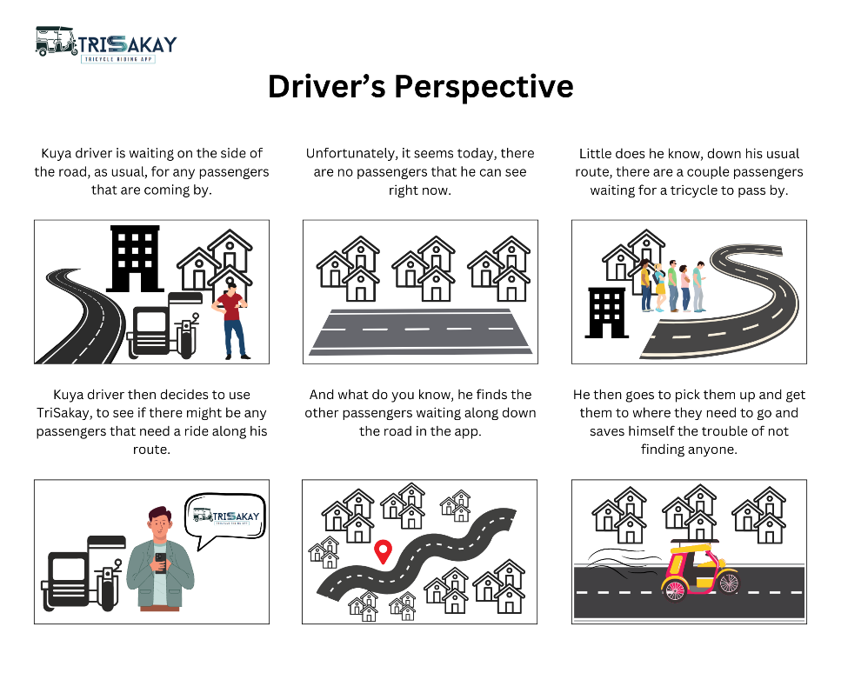

**Loading Page & Sign-in Page**

 

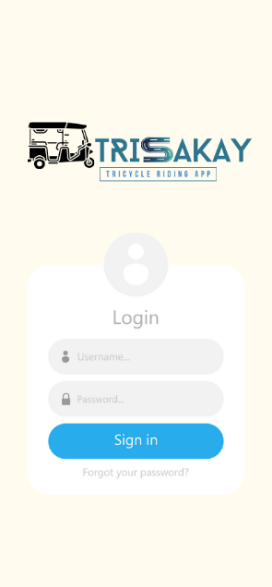 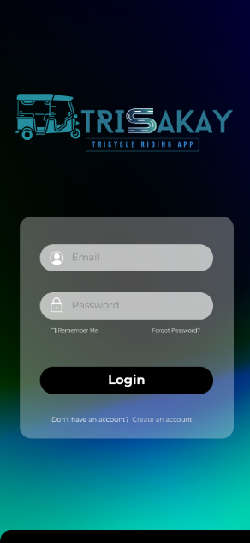

**Advantages:**

* Simple, easy to look at screen
* Straightforward

**Disadvantages:**

* Other login options are unavailable

**Passenger/Driver Landing Page**

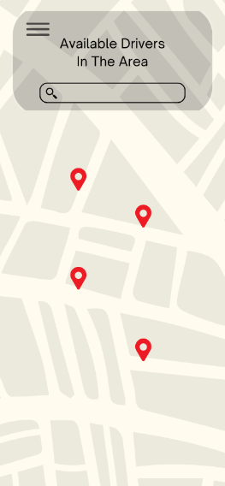 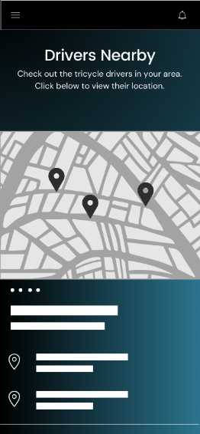

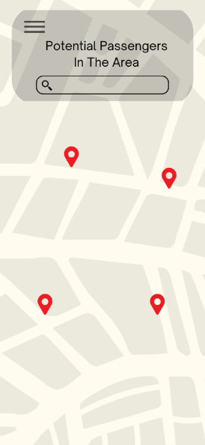 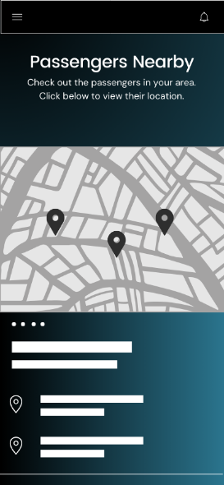

**Advantages:**

* Easy to navigate interfaces
* Clear view of legends (pins of passengers or drivers)
* Access to other options via sidebar

**Disadvantages:**

* Design on Left: Extremely minimalistic; not much information
* Design on Right: Map size may be too small for some users

**Sidebar**

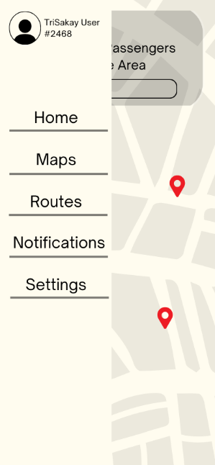 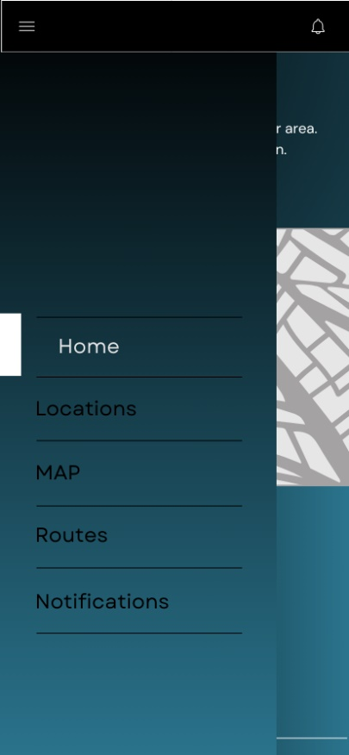

**Advantages:**

* Convenient access to other options readily available
* Access to full-size map with zooming features for better viewing
* Can view common routes taken

**Disadvantages:**

* Both designs take up a sizable amount of the screen
* Accessibility may be inconvenient due to use of a sidebar

**Notifications**

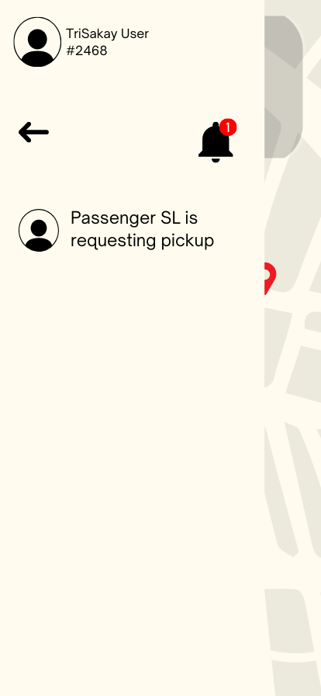 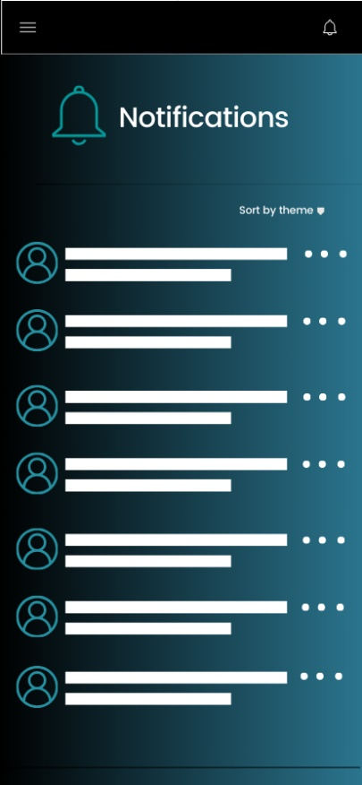

**Advantages:**

* Allows users to be notified of any changes that may be happening (i.e. new available driver or passenger)

**Disadvantages:**

* Notifications may be distracting if abused by users

1. **Requirements Changes**

During the design phase, the following designs were created in addition to the original designs made:

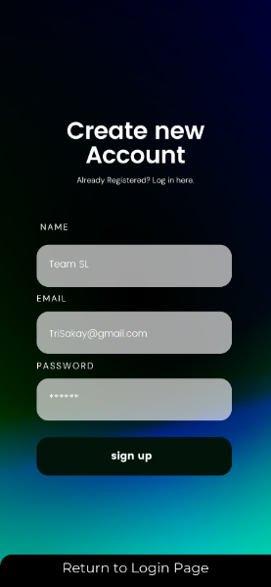 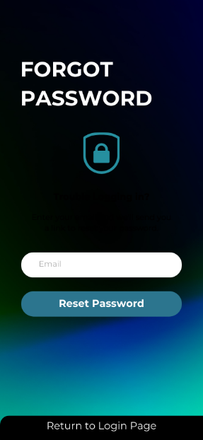 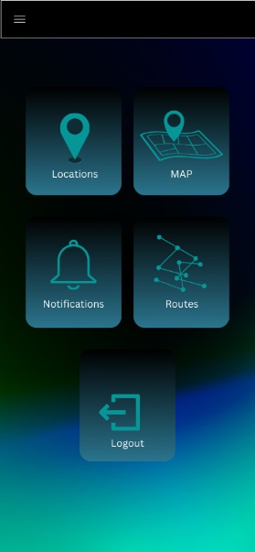 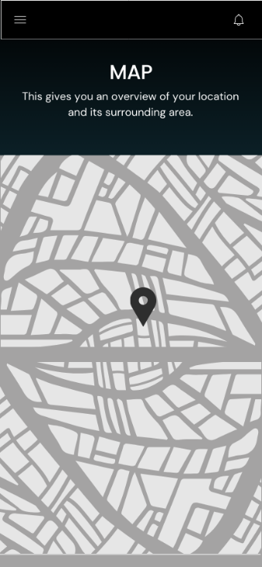 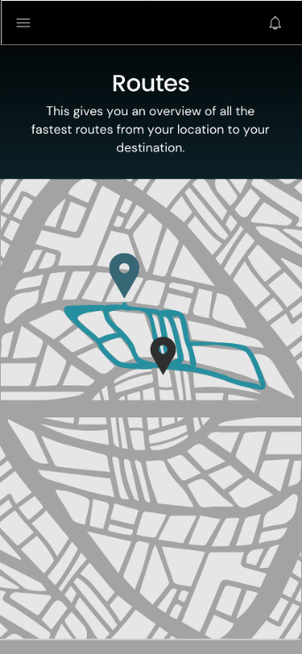

Each additional design will be discussed in further detail below:

**Sign-up Page**

With the addition of a login page for the app, it would be appropriate for a sign-up page to be implemented as well, to ensure that users will not have to register from a 3rd party app and can instead opt to make a new account from the TriSakay app itself.

**Forgot Password Function**

In modern login systems, this function is commonly used to ensure users do not accidentally lose their accounts, granted that they have linked an email to their account to reset their password from their email.

**Dedicated Home Page**

This design, while not final, may be added to the app to grant more accessibility for users that the sidebar may fail to ensure. Having a dedicated home page may also improve user experience by allowing them to focus on one function at a time.

**Maps & Routes Function**

These two functions, while distinct, perform similar tasks using the app’s built-in maps system, with the maps function simply allowing a user to fully interact with the map by being able to zoom in and out, while the routes function allows a user to view routes that are commonly taken by tricycle drivers.